Lesson 30 Quiz
1) C
2)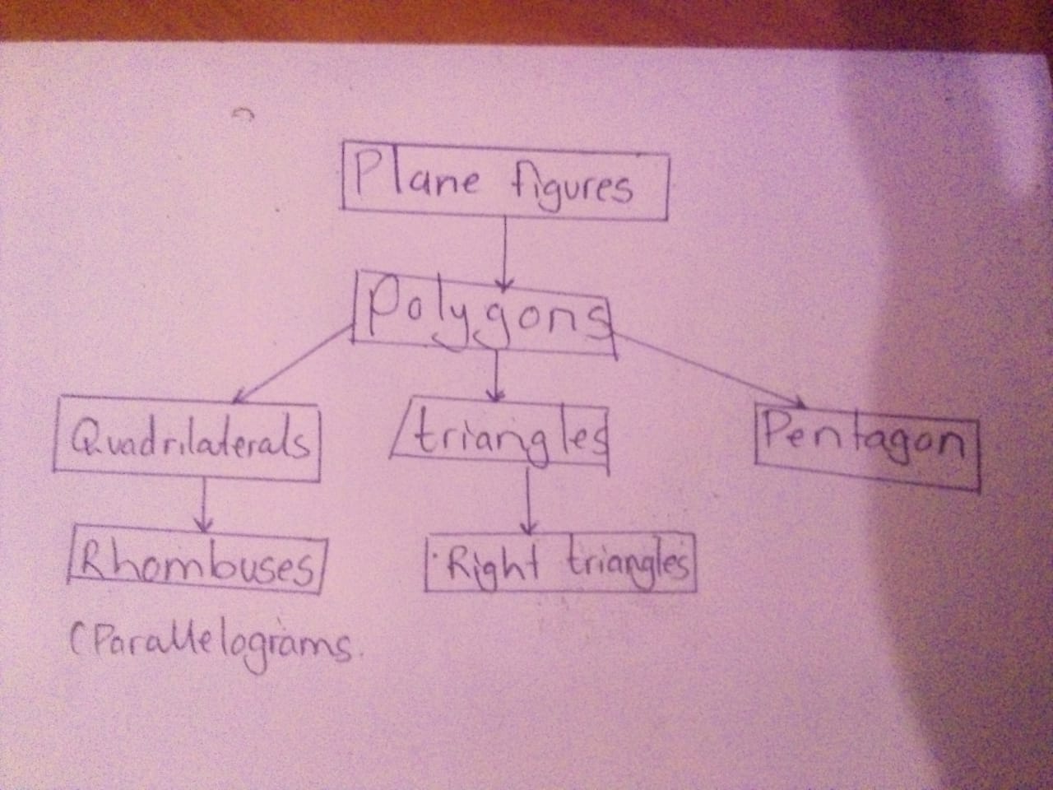
3)
A) Never
B) Sometimes
c) Never
d) Never
e) Always
f) Never

4)B

